# PROJECT AND TEAM INFORMATION

## Project Title

(Try to choose a catchy title. Max 20 words).

Document Verifier

Student / Team Information

|  |  |
| --- | --- |
| *Team Name: Team #* | *Cyber Core* |
| **Team member 1 (Team Lead)**  *(Last Name, name: student ID: email, picture):* | Pacholi, Mayank-23011958  [pacholimayank9@gmail.com](mailto:pacholimayank9@gmail.com) |
| **Team member 2**  *(Last Name, name: student ID: email, picture):* | *Singh, Jatin-23011594*  [*Jatinkathayat4@gmail.com*](mailto:Jatinkathayat4@gmail.com) |
| **Team member 3**  *(Last Name, name: student ID: email, picture):* | *Bhatt, Hrishita-230124943*  [*hrishitahh@gmail.com*](mailto:hrishitahh@gmail.com) |
| **Team member 4**  *(Last Name, name: student ID: email, picture):* | *Bajeli, Mansi – 23012904*  [*bajeli42115@gmail.com*](mailto:bajeli42115@gmail.com) |

# PROPOSAL DESCRIPTION (10 pts)

## Motivation (1 pt)

(Describe the problem you want to solve and why it is important. Max 300 words).

Legal documents, such as contracts, wills, property deeds, and court records, are critical for upholding justice and ensuring fair transactions. However, traditional digital storage methods are vulnerable to tampering, forgery, and unauthorized alterations, which can compromise their admissibility in court. Verifying the authenticity of legal documents often requires extensive manual effort, leading to delays, increased costs, and potential legal disputes.

A Legal Document Integrity Verifier (LDIV) using blockchain technology ensures that legal documents remain untampered and verifiable using blockchain and cryptographic hashing. It allows users to upload documents, store their cryptographic fingerprints (hashes) on a blockchain, and later verify their integrity.

## 

## State of the Art / Current solution (1 pt)

(Describe how the problem is solved today (if it is). Max 200 words).

Today, we solved the problem of legal document tampering and authenticity verification by implementing a blockchain-based Legal Document Integrity Verifier (LDIV). Traditional digital legal documents are vulnerable to forgery and unauthorized modifications, making court admissibility difficult and increasing the risk of legal disputes. Manual verification processes are slow, costly, and prone to errors. Our solution leverages blockchain’s immutability and cryptographic security to create a tamper-proof system where document hashes are stored on a decentralized ledger. Once a document is registered, its authenticity can be verified instantly by comparing its hash with the blockchain record. Any unauthorized modification changes the hash, making tampering immediately detectable. This system prevents document fraud, enhances legal credibility, streamlines verification, and ensures documents remain legally admissible. By integrating blockchain, we established a secure, transparent, and efficient method for legal document verification, strengthening trust in the legal system and reducing the risks associated with document manipulation.

## 

## Project Goals and Milestones (2 pts)

(Describe the project general goals. Include initial milestones as well any other milestones. Max 300 words).

The Legal Document Integrity Verifier (LDIV) aims to prevent document tampering and ensure authenticity using blockchain. It provides a secure, transparent, and efficient way to verify legal documents, enhancing court admissibility and trust.

**Milestones:**

a- Set up the basic Flask web application with routes for file upload and verification.

b- Design a simple user interface to allow users to upload and verify documents easily.

c- Implement file hashing using SHA-256 to generate unique digital fingerprints.

d-Create a simple blockchain structure to store each hash as a new block.

e- Enable document verificatio**n** by comparing the uploaded file’s hash with stored blockchain entries.

## Project Approach (3 pts)

(Describe how you plan to articulate and design a solution. Including platforms and technologies that you will use. Max 300 words).

To ensure the integrity and authenticity of legal documents, we will design a blockchain-based verification system that provides tamper-proof storage, real-time verification, and easy accessibility. The system will generate a unique cryptographic hash for each document, which will be stored on the blockchain. Users can verify document integrity by comparing a newly generated hash with the stored one.

**a-**Programming Language: Python (Flask)

**b-**HTML , CSS for frontend

**c-**Flask(python) for backend

**d-**Blockchain: custom built blockchain

**e-**Hashing: SHA-256 (Python’s hashlib )

## System Architecture (High Level Diagram)(2 pts)

(Provide an overview of the system, identifying its main components and interfaces in the form of a diagram using a tool of your choice).

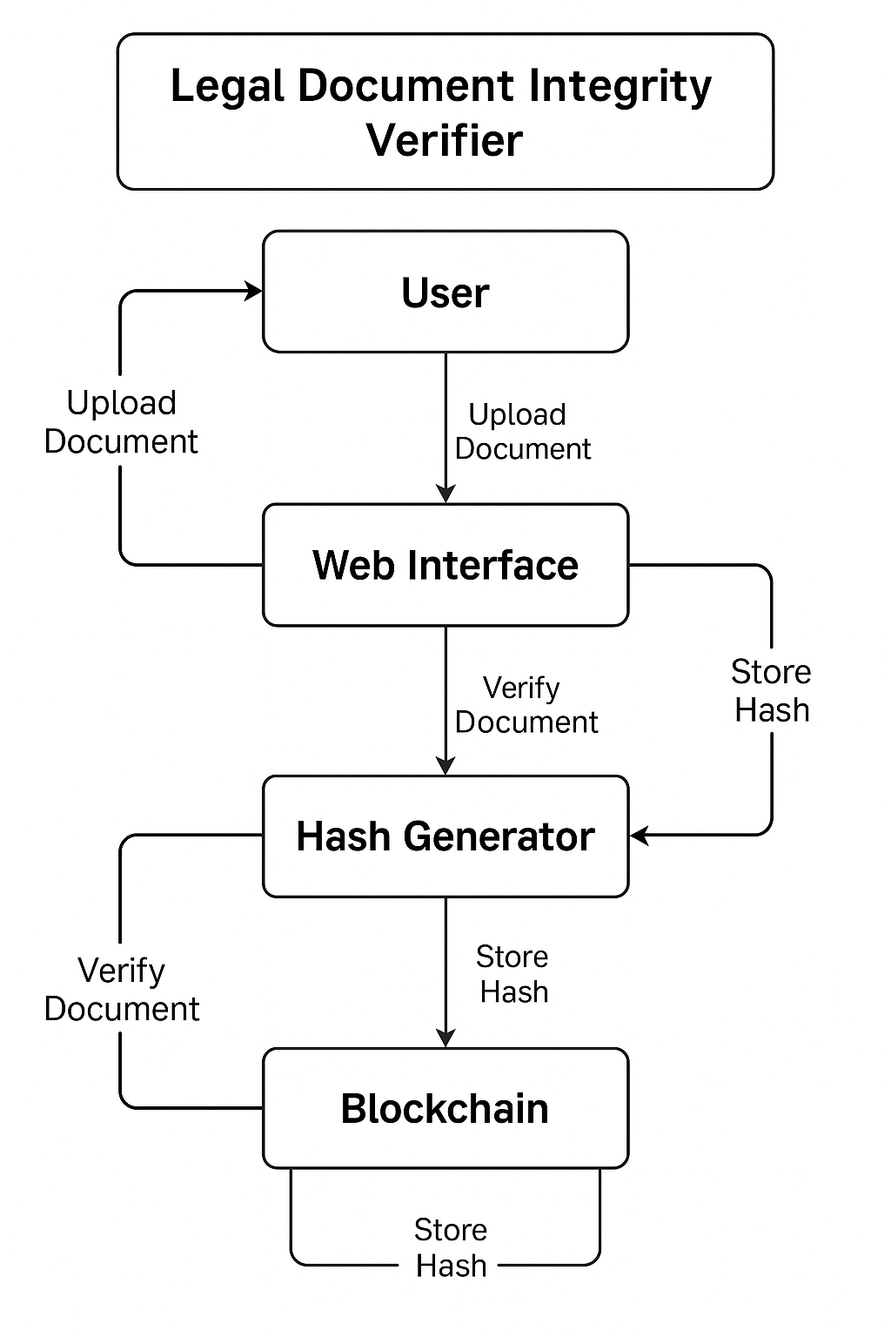

## 

## Project Outcome / Deliverables (1 pts)

(Describe what are the outcomes / deliverables of the project. Max 200 words).

The Legal Document Integrity Verifier (LDIV) ensures secure, tamper-proof verification of legal documents using blockchain.

**Key Outcomes:**

Immutable document verification to prevent tampering.

Enhanced legal admissibility for court use.

Automated, efficient verification reducing manual effort.

**Deliverables:**

Web & Mobile Application for document registration and verification.

Blockchain Smart Contracts for storing document hashes.

Backend API for secure data processing.

Security Framework (RBAC, MFA).

System Documentation for users and developers

## Assumptions

( Describe the assumptions ( if any ) you are making to solve the problem. Max 100 words )

Legal Acceptance – Courts and legal institutions recognize blockchain-based verification as admissible evidence.

User Trust – Legal professionals and businesses adopt the system for document integrity verification.

Stable Blockchain Network – The chosen blockchain (Ethereum/Hyperledger) remains secure and operational.

Accurate Hashing – Document hashes are unique, ensuring no two different documents generate the same hash.

Internet Connectivity – Users have stable internet access for real-time verification.

These assumptions ensure the system's effectiveness and legal credibility.

## 

## References

(Provide a list of resources or references you utilised for the completion of this deliverable. You may provide links).

**1.**Ethereum Documentation: https://ethereum.org/en/developers/docs/

**2.**Cryptographic Hashing & Security:SHA-256 Algorithm: https://en.wikipedia.org/wiki/SHA-2

**4**.**.**Backend & API Development:

Node.js Documentation: https://nodejs.org/en/docs/

Express.js Guide: https://expressjs.com/en/guide/routing.

**4.**Legal Framework for Blockchain Evidence:

Blockchain & Legal Admissibility: https://www.natlawreview.com/article/blockchain-evidence-legal-admissibility